

[Grab your reader’s attention with a great quote from the document or use this space to emphasize a key point. To place this text box anywhere on the page, just drag it.]

**EEE1024: Fundamentals of Electrical and Electronics Engineering**

**Dr. Sanchit Khatavkar**

Sinusoidal form Phasors

*v*(*t*)  *Vm*

cos(*t* * o*)

*V*  *V** o*

Phasors Complex numbers (rectangular form )

*V*  *V** o*

*m*

*z*  *x*  *iy*

Phasors Sinusoidal form



RECAP

*V*  *V** o*

*V* cos(*t* * o* )

Units for all 3 – same – Ohms (Ω)

*R*  *V*

## I

LOAD -

Resistor

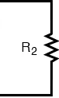

LOAD -

pure Capacitor



LOAD -

pure Inductor

#### REACTANCE

***- X (Ω)***

*X*  *V*

## I

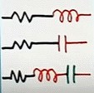If LOAD -

R-L load R-C load

R-L-C load

#### IMPEDANCE – Z (Ω)

*Z*  *V*

## I

Inductive circuit

*iL* Sinusoidal current flowing



through inductor

 …………………………….. Voltage across inductor



Phasor for current - 

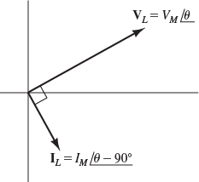Phasor for voltage - 



*Current lags Voltage by 90ο*



 *LI* (* o*  90*o*  900)

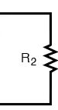

Inductive circuit

*iL*

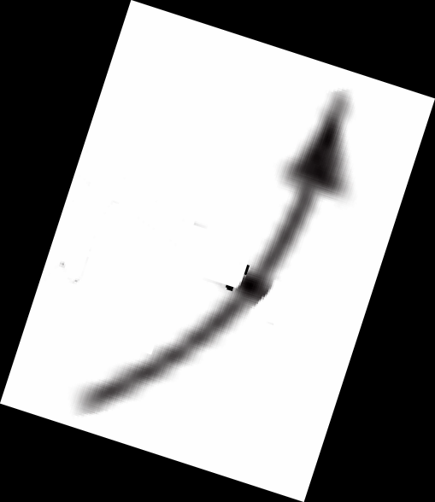

*m*





………………………………………



- Impedance of the inductance

*ZL*



…………………………

Capacitive circuit

Like,

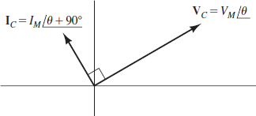



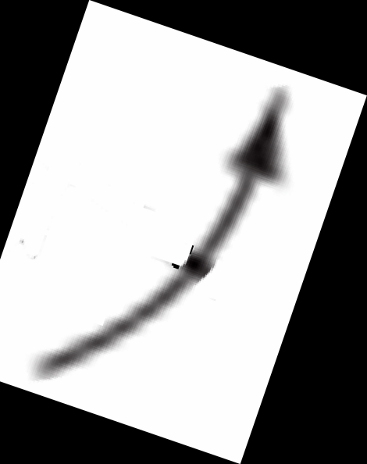*Current LEADS Voltage by 90ο*

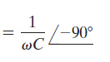

If a phasor voltage Vc is



Resistive circuit

 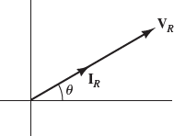



Voltage and Current phasors are ***- INPHASE***

#### IMPEDANCES of

***Capacitances/Inductances***

Combined as ***Resistances***

Example –

Determine the complex impedance between terminals shpwn in the figure. ω = 1000 rad/s

Step 1: Calculate *impedances*

*Z*   *j*

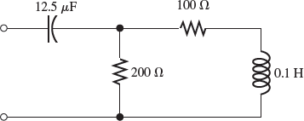*c C*

*Z*   *j*

*ZL* 

*jL*

*c*

*Zc* 

1000 12.5106

# 1

1000 12.5106

*ZL* 



COMBINING IMPEDANCES IN SERIES & PARALLEL(1)

*j* 1000  0.1  100 *j*

 80 *j*

COMBINING IMPEDANCES IN SERIES & PARALLEL(2)

*Zc*  80 *j* Ω

Step 1: Calculate *impedances- DONE*

*ZL*  100 *j* Ω

Step 2:

*Find equivalent resistance in the “ALL RESISTANCE -like” Circuit*

100 Ω and 100j Ω - in series

100+100j

###  1

( 1  1

200 Ω and 100+100j Ω - in parallel

### )

200 100 100 *j*

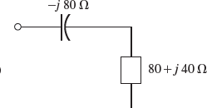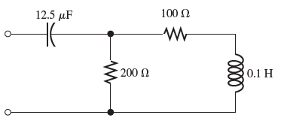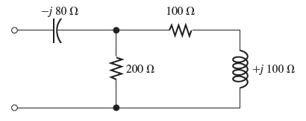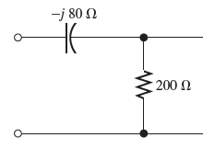

=1/(1/200+1/(100+100i)) =80+40i

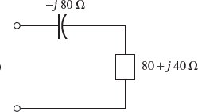ANS

Example 2: A voltage

*vL* (*t*)

#  100 cos(200*t*)

is applied to a 0.25H inductance.

Notice that ω=200 rad/s.

1. Find impedance of inductance, phasor current and phasor voltage (of inductor)
2. Draw phasor diagram

Example 3: A voltage

*vC* (*t*)  100 cos(200*t*)is applied to a 100µF capacitance.

1. Find impedance of capacitance, phasor current and phasor voltage (of capacitor)



COMBINING IMPEDANCES IN SERIES & PARALLEL(3)

1. Draw phasor diagram





CIRCUIT ANALYSIS with PHASORS and COMPLEX IMPEDANCES

KIRCHOFF’S LAWS

NODE VOLTAGE ANALYSIS

MESH CURRENT ANALYSIS

Steady state AC analysis of an AC circuit

Example:

1. Find the steady state current in the given circuit

Step 1: Calculate *impedances*

1. Find the voltage across each

element in the circuit and construct 

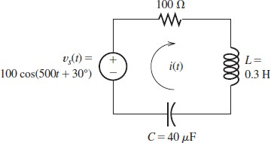a phasor diagram

Step 2: Replace v(t) by phasors

*Vs*

Step 3a: Use KVL

100*I*

 (150*i*)*I*

 (50*i*)*I*  0

### 10030  100(cos(30)  *i* sin(30))

 100(0.866  *i*(0.5))

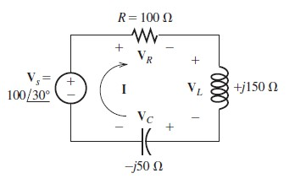

Step 2: Replace v(t) and i(t) by phasors

*Vs*  (100 150*i*  50*i*)*I Vs*  (100 100*i*)*I*

*I*  86  50*i*

### 100 100*i*

 86  50*i*

*I*  *Vs*

### 100 100*i*

 10030 100 100*i*

*I*  (86  50*i*) 

### (100 100*i*)

(100 100*i*)

(100 100*i*)

 0.68  0.18*i*

Step 3b: Use the properties of a series circuit

Series circuit – Current remains same!

*Z*  *V*

*I*







Step 4: Calculate voltages across each element





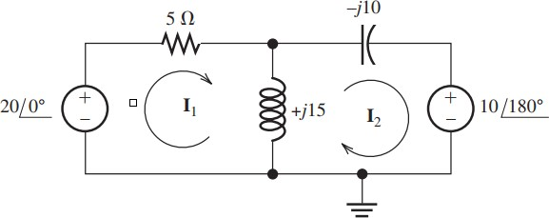

MESH CURRENT ANALYSIS

@Loop1

− 200  *I*1 (5)  (*I*1  *I*2 )15 *j*  0

@Loop2



CIRCUIT ANALYSIS with PHASORS and COMPLEX IMPEDANCES

10180  (*I*2

− *I*1 )15 *j*  *I*2 (10

*j*)  0

ACPower Calculations



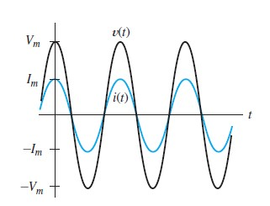



RESISTIVE Load





INDUCTIVE Load



CAPACITIVE

Load









RLC load where phase θ can be any value from

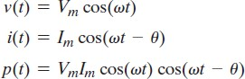

Average Power

*V*

*rm s*

 *Vm*

2

*I*

*rms*

 *Im*

2



Average Power – ACTIVE power

Units: W

– POWER FACTOR

RLC load where phase θ can be any value from

ACTIVE power  Units: W

POWER FACTOR  For phase θ = 0o

For phase θ value other than 0o



θv = Phase of voltage θi = Phase of current

REACTIVE Power  Units: VAR APPARENT Power Units: VA